Name Date

Practice Assessment

Chapter

3

Use the figure to find the measure of the angle. Explain your reasoning.

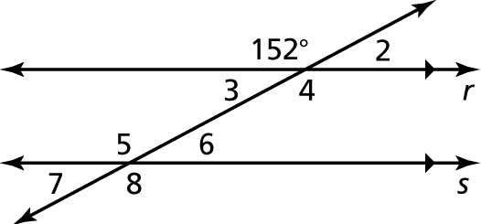 1. 

2. 

3. 

4. 

Find the measures of the interior angles.

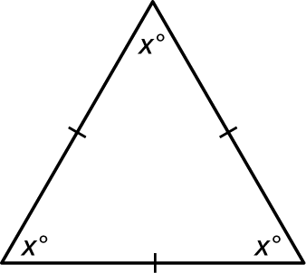 5. 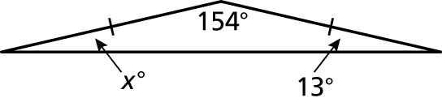 6.

Find the measure of the exterior angle.

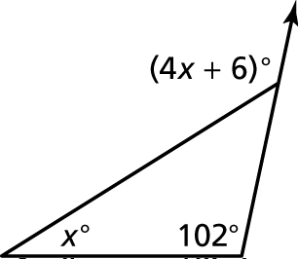 7. 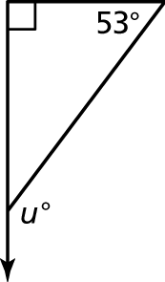 8.

Find the measures of the interior angles of the polygon.

9. 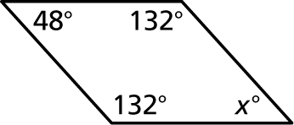 10. 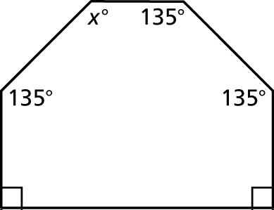

Name Date

Practice Test

Chapter

3

**Tell whether the triangles are similar. Explain.**

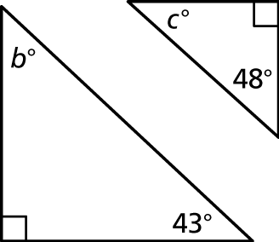 13. 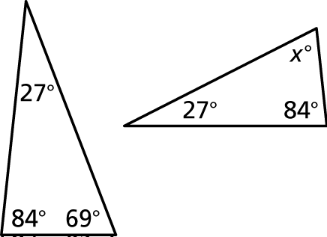 14.

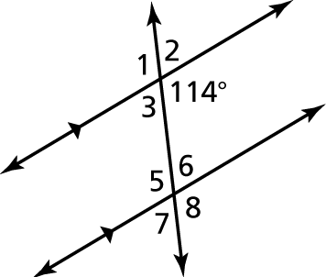 15. Describe two ways you can find   
the measure of 

**16.** Use the diagram below to answer the questions that follow.  The length of each segment is as shown:

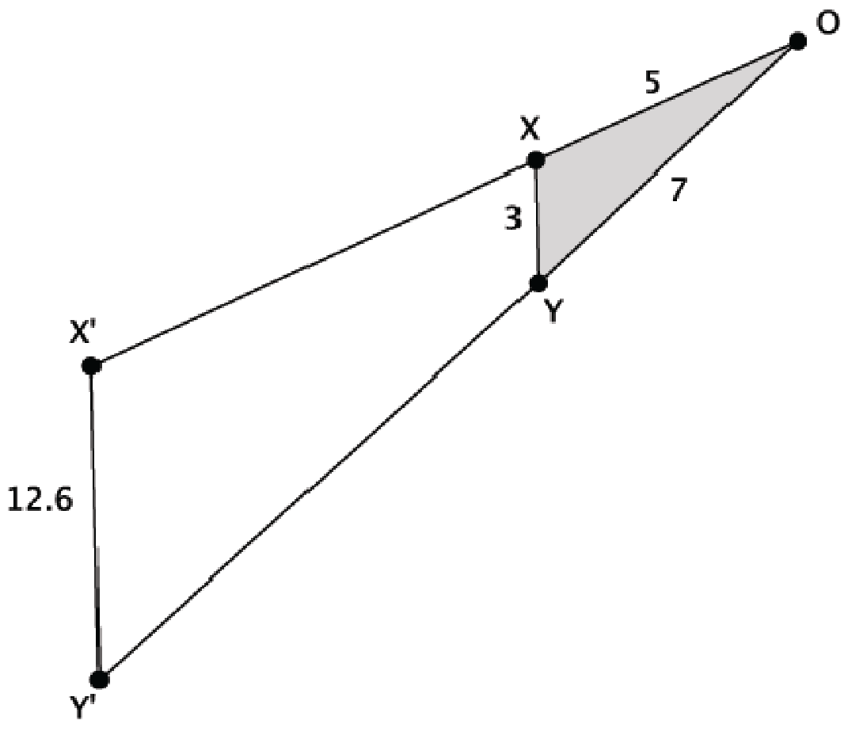

1. Suppose XY is parallel to X'Y'.  Is ΔOXY similar to ΔOX’Y’?  Explain.
2. What is the length of segment OX’?  Show your work.
3. What is the length of segment OY’?  Show your work.